Commands

1. **To Run Zookeeper**
   1. zookeeper-server-start.bat <root>/etc/kafka/zookeeper.properties
2. **To Run Kafka Broker**:
   1. kafka-server-server.bat <root>/etc/kafka/server.properties
3. **To Create Topic**
   1. kafka-topic.bat --create --topic <name> --partitions <#> --replication-factor <#> bootstrap-server <comma-list>
4. **To Run Kafka Console Producer**
   1. kafka-console-producer --topic --broker-list <comma-list> < <Data-file>
5. **To run Kafka Console Consumer**
   1. kafka-console-consumer --topic --bootstrap-server <comma-list> --from-beginning

9. Installing Single Node Kafka Cluster

1. Download Community Version from Confluent.io
2. Graphical user interface, funnel chart

   Description automatically generated
3. A screenshot of a computer

   Description automatically generated
4. A screenshot of a computer

   Description automatically generated  
   Till now, we downloaded Community Edition of Confluent. It also provides Commercial Edition too.

1. Let’s start Kafka Server/Cluster which is Two-Step Process.
2. **Step 01**: Starting Zookeeper Server.  
   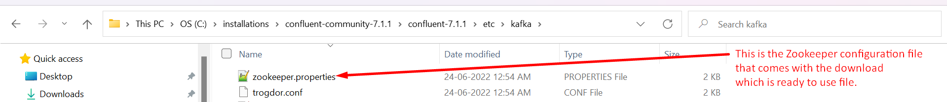  
   

* + 1. **rem Classpath addition for LSB style path**

**if exist %BASE_DIR%\share\java\kafka\* (**

**call :concat %BASE_DIR%\share\java\kafka\\***

**)**

1. **Step 02**: Run Kafka Broker.  
     
   Great!!! We created Single-Node Kafka Cluster.



1. We will use this script to do anything with a topic 🡺 
2. Command to create Topic 🡺   
   
3. **Command options**:
4. **--create** : To create a topic.
5. **--partition**: To specify the partition #.
6. **--replication-factor**: # of copies for each partition.
7. **--bootstrap-server**: a subset of Kafka Brokers for Kafka Clients (Producer & Consumer) to connect initially with Kafka Cluster’s Brokers.



1. We will use this script to send data from console to Kafka Cluster.  
   
2. Command to read and send a Data File to Kafka Server.A screen shot of a computer

   Description automatically generated with low confidence



1. Command to consume msgs from Kafka Server.  
   